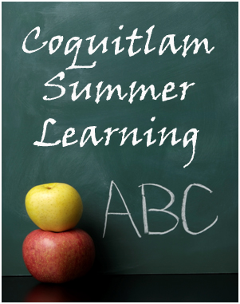
SUMMER LEARNING 2014 ONLINE Registration Dates (6:00 a.m. Opening)
Elementary Skill Building: May 29th

Students must have an account with our online system BEFORE registering for courses. Please visit our website and create/update your account now.

We are offering courses in Fine Arts, French Immersion, Reading & Writing, Math and Science! See website for full details!

Program Dates: July 8 to July 25
Visit www.summerlearningcoquitlam.ca

